BASIS DATA

Nama : Rizki Faro Khatiningsih

Nim : 2018081310

Fakultas : Ilmu Komputer

**DESC PRODUCT_NOV**

INSERT INTO PRODUCT_NOV

VALUES('01','MANGGA','BUAH','3000','3500','-','-')

SELECT * FROM PRODUCT_NOV

INSERT INTO PRODUCT_NOV

VALUES('02','BAYAM','SAYUR','4000','5000','-','-')

SELECT * FROM PRODUCT_NOV

INSERT INTO PRODUCT_NOV

VALUES('03','DURIAN','BUAH','50000','85000','-','-')

SELECT * FROM PRODUCT_NOV

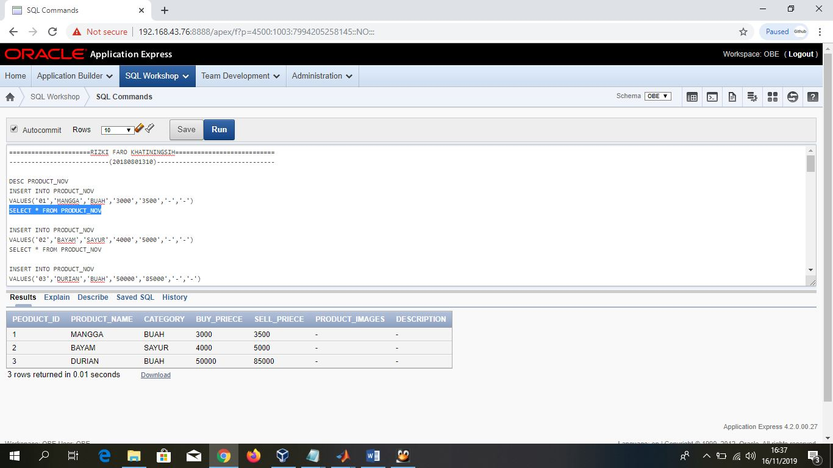

**DESC STOCK_NOV**

INSERT INTO STOCK_NOV

VALUES('01','15','06/05/2019','001')

SELECT * FROM STOCK_NOV

INSERT INTO STOCK_NOV

VALUES('02','20','07/08/2019','002')

SELECT * FROM STOCK_NOV

INSERT INTO STOCK_NOV

VALUES('03','18','08/09/2019','003')

SELECT * FROM STOCK_NOV

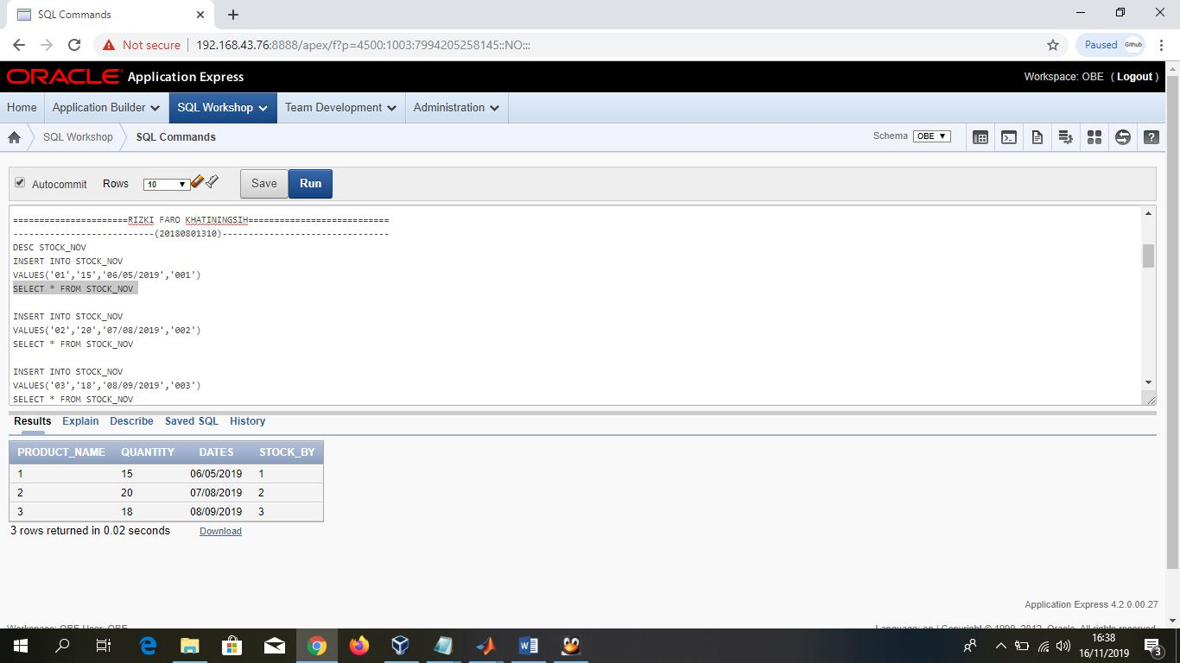

**DESC CUSTOMER_NOV**

INSERT INTO CUSTOMER_NOV

VALUES('01','REGINA','INDAH','CAHYANI','CITRA RAYA','regina12@gmail.com','000000000001')

SELECT * FROM CUSTOMER_NOV

INSERT INTO CUSTOMER_NOV

VALUES('02','AULIA','BUNGA','RIYANI','PASIR GADUNG','aul23@gmail.com','000000000002')

SELECT * FROM CUSTOMER_NOV

INSERT INTO CUSTOMER_NOV

VALUES('03','RIZKI','FARO','KHATININGISH','PANONGAN','faro34@gmail.com','000000000003')

SELECT * FROM CUSTOMER_NOV

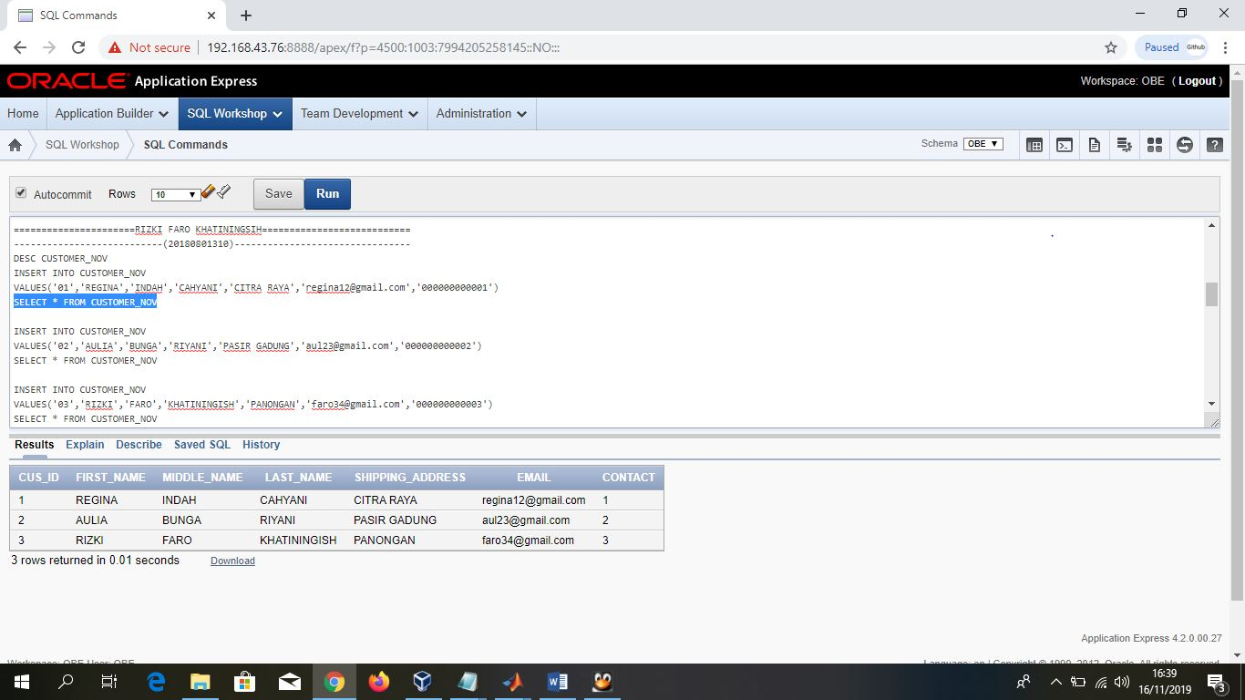

**DESC ORDER_NOV**

INSERT INTO ORDER_NOV

VALUES('01','01','05/05/2019','DELIVE')

SELECT * FROM ORDER_NOV

INSERT INTO ORDER_NOV

VALUES('02','02','06/09/2019','CANCEL')

SELECT * FROM ORDER_NOV

INSERT INTO ORDER_NOV

VALUES('03','03','08/07/2019','DELIVE')

SELECT * FROM ORDER_NOV

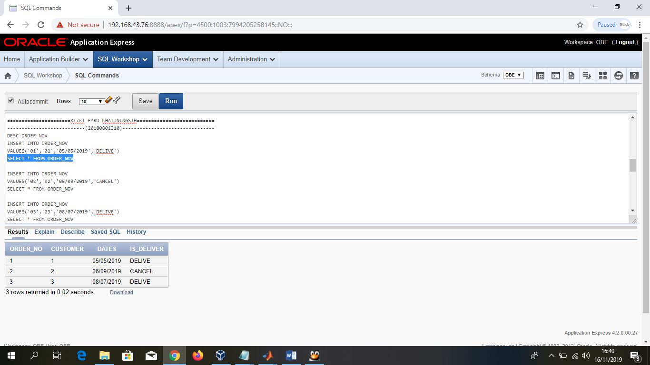

**DESC ORDER_DETAILS_NOV**

INSERT INTO ORDER_DETAILS_NOV

VALUES('01','01','15')

SELECT * FROM ORDER_DETAILS_NOV

INSERT INTO ORDER_DETAILS_NOV

VALUES('02','02','20')

SELECT * FROM ORDER_DETAILS_NOV

INSERT INTO ORDER_DETAILS_NOV

VALUES('03','03','18')

SELECT * FROM ORDER_DETAILS_NOV

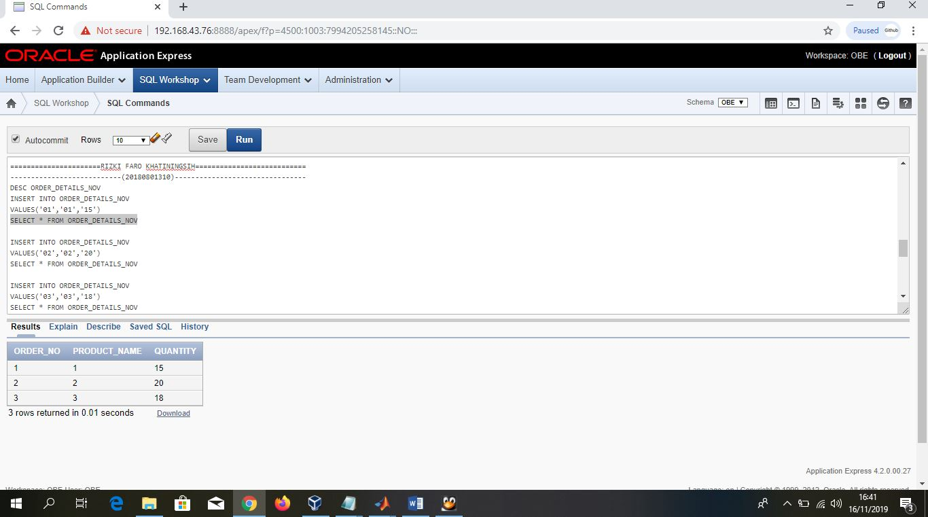

**>> NO.6**

SELECT a.ORDER_NO, a.DATES, c.FIRST_NAME, b.PRODUCT_NAME, b.QUANTITY, d.SELL_PRIECE,

b.quantity*d.SELL_PRIECE as total

FROM ORDER_NOV a, ORDER_DETAILS_NOV b,CUSTOMER_NOV c, PRODUCT_NOV d

WHERE b.ORDER_NO = a.ORDER_NO and c.CUS_ID = a.CUSTOMER and b.PRODUCT_NAME = d.PEODUCT_ID

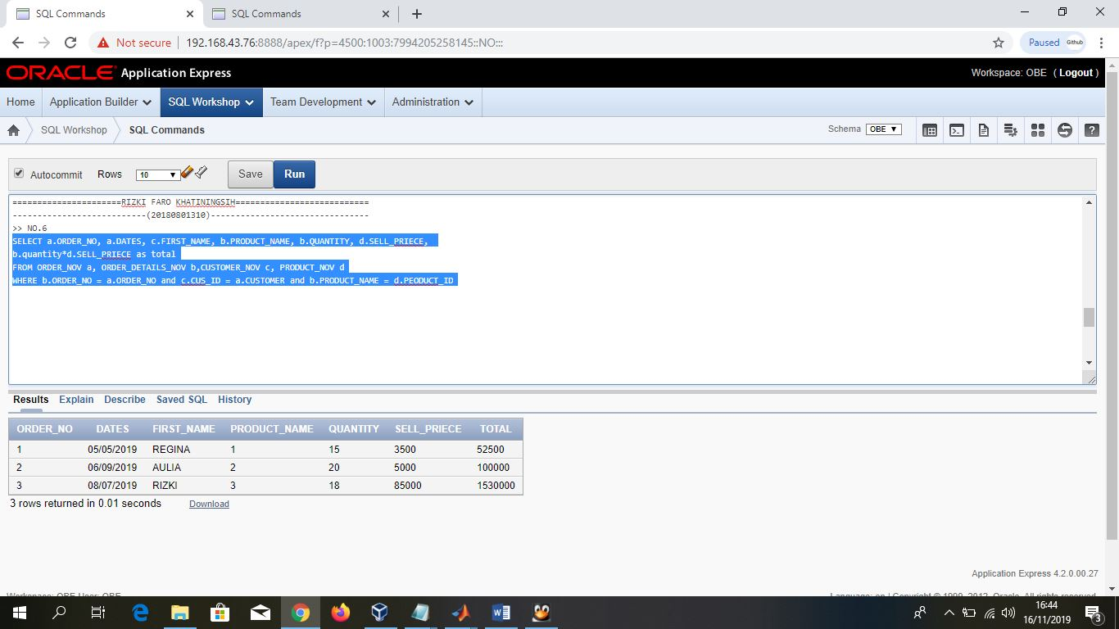

**>> NO.7**

SELECT PRODUCT_NAME, sum(QUANTITY)

FROM ORDER_DETAILS_NOV

Group By PRODUCT_NAME,QUANTITY

Order by QUANTITY desc

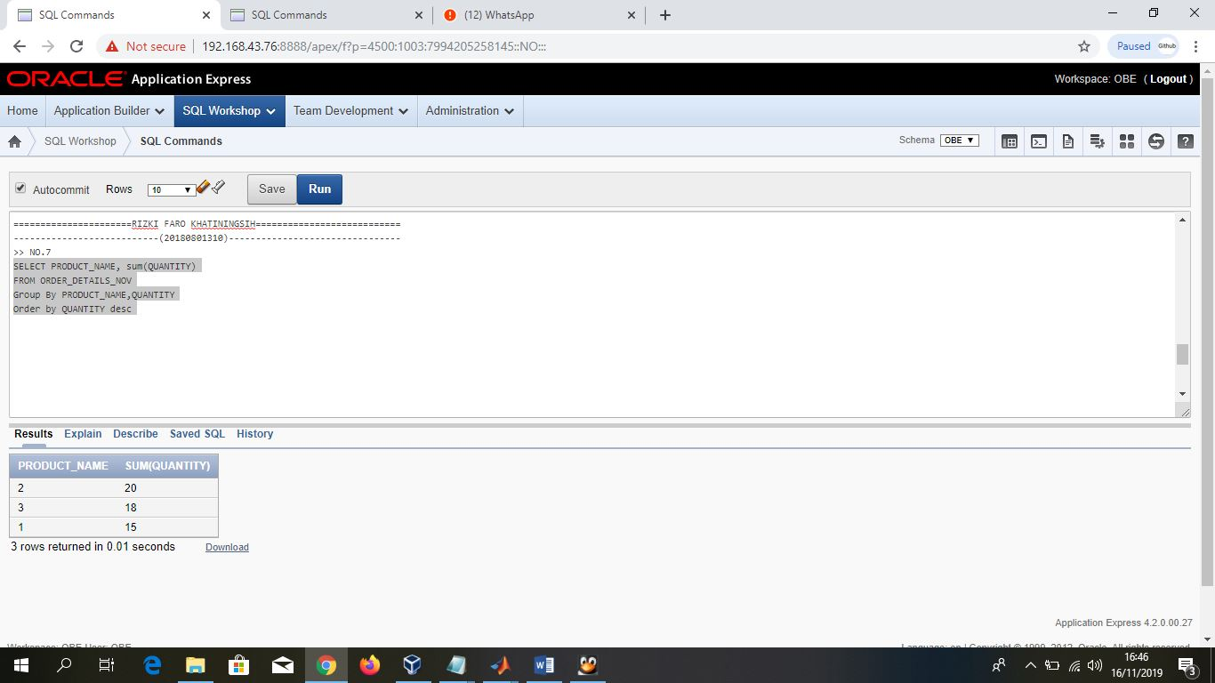

**>> NO.8**

SELECT a.DATES,b.PRODUCT_NAME,sum(b.QUANTITY),

persentase = (sum(b.QUANTITY)/

SELECT sum(d.QUANTITY)

FROM ORDER_NOV c,ORDER_DETAILS_NOV d

WHERE d.ORDER_NO = c.ORDER_NO and c.DATES = '2019-11-16')*100

FROM ORDER_NOV a, ORDER_DETAILS_NOV b

WHERE b.ORDER_NO = a.order_no and a.DATES = '2019-11-16'

GROUB BY a.DATES,b.PRODUCT_NAME,b.QUANTITY